SECTION A
1. Name Uganda’s neighbouring country to the North.
_______________________________________________________________________
_______________________________________________________________________
2. Give the name of river Nile between Lake Kyoga and Lake Albert.
_______________________________________________________________________
_______________________________________________________________________
3. What type of vegetation covers the largest part of Uganda?
_______________________________________________________________________
_______________________________________________________________________
4. Write N.E.M.A in full.
_______________________________________________________________________
_______________________________________________________________________
5. State the major use of Longitudes and Latitudes on a map.
_______________________________________________________________________
_______________________________________________________________________
6. Give one reason why air transport is used to transport flowers over long distances.
_______________________________________________________________________
_______________________________________________________________________
7. Mention any one natural resource in Uganda.
_______________________________________________________________________
_______________________________________________________________________
8. Name the weather instrument that is placed in a flat open ground.
_______________________________________________________________________
_______________________________________________________________________
9. What is the main occupation of most people in Central Uganda?
_______________________________________________________________________
_______________________________________________________________________
10. Why is port Mombasa important to the economy of Uganda?
_______________________________________________________________________
_______________________________________________________________________
11. In the space provided below, draw the map symbol for a rift valley.

12. Give one reason why elephants need to be protected from poachers.
_______________________________________________________________________
_______________________________________________________________________
13. What is a community?
_______________________________________________________________________
_______________________________________________________________________
14. Give any one problem that a school without a library is likely to face.
_______________________________________________________________________
_______________________________________________________________________
15. State the source of hardwood in Uganda.
_______________________________________________________________________
_______________________________________________________________________
16. What is the use of a Zebra-crossing on busy roads?
_______________________________________________________________________
_______________________________________________________________________
17. How is soil erosion in hilly areas controlled?
_______________________________________________________________________
_______________________________________________________________________
18. Who is the chairman of the Electoral Commission in Uganda?
_______________________________________________________________________
_______________________________________________________________________
19. Why is the 9th October a public holiday in Uganda?
_______________________________________________________________________
_______________________________________________________________________
20. State any one way in which electricity is useful in factories.
_______________________________________________________________________
_______________________________________________________________________
21. Give the work of a Resident District Commissioner.
_______________________________________________________________________
_______________________________________________________________________
22. How are the Bahima and Karimojongs similar in their occupation?
_______________________________________________________________________
_______________________________________________________________________

23. Why do crop farmers harvest their crops in the dry season?
_______________________________________________________________________
_______________________________________________________________________
24. What is a National Constitution?
_______________________________________________________________________
_______________________________________________________________________
25. How was Mt. Mufumbiro formed?
_______________________________________________________________________
_______________________________________________________________________
26. There are three organs of a democratic government; Legislature, Executive and Judiciary. Which of these organs is responsible for punishing lawbreakers?
_______________________________________________________________________
_______________________________________________________________________
27. Name any one organization which helps the needy people in Uganda.
_______________________________________________________________________
_______________________________________________________________________
The diagram below shows a tool used by early man. Use it to answer question 28.

28. How useful was the tool above to early man?
_______________________________________________________________________
_______________________________________________________________________
29. How do people benefit from swamps?
_______________________________________________________________________
_______________________________________________________________________
30. What cultural ceremony among the Bagisu turns boys into men?
_______________________________________________________________________
_______________________________________________________________________
31. What is the use of a class timetable?
_______________________________________________________________________
_______________________________________________________________________
32. Give any one group of people who keep security in a community.
_______________________________________________________________________
_______________________________________________________________________
33. Why did Gipiir and Labong separate?
_______________________________________________________________________
_______________________________________________________________________
34. Give the reason why the Equator is marked 0⁰.
_______________________________________________________________________
_______________________________________________________________________
35. Name the first ethnic group to migrate into Uganda.
_______________________________________________________________________
_______________________________________________________________________
36. Why is Ahmed-bin-Ibrahim remembered in the history of Uganda?
_______________________________________________________________________
_______________________________________________________________________
For questions 37 to 40, answer EITHER the Christian OR Islamic question but not both. No marks will be awarded to a candidate who attempts both alternatives.
37. Either: Mention the religion that existed in Uganda before introduction of Christianity and Islam. ____________________________________________________________________
Or: Name the first foreign religion in Uganda.
____________________________________________________________________
38. Either: When does a Christian become a member of God’s family?
____________________________________________________________________
____________________________________________________________________
Or: When does a person who is not born by Muslim parents become a Muslim?
____________________________________________________________________
____________________________________________________________________
39. Either: Who was the first Christian martyr, according to the Bible?
____________________________________________________________________
Or: Who was the first caliph of Prophet Muhammed?
____________________________________________________________________
40. Either: Why is Mountain Sinai important to Christians?
____________________________________________________________________
____________________________________________________________________
Or: Why is Mountain Hira important to Muslims?
____________________________________________________________________
____________________________________________________________________
SECTION B
41. Study the climatic table of place A below and answer the questions that follow.
CLIMATE OF PLACE A
Months | J | F | M | A | M | J | J | A | S | O | N | D
Rainfall(mm) | 80 | 85 | 100 | 120 | 110 | 80 | 30 | 70 | 90 | 115 | 95 | 90
Temperature ⁰C | 20 | 22 | 28 | 28 | 25 | 21 | 20 | 24 | 29 | 25 | 23 | 21

- Which was the wettest month in place A?
____________________________________________________________________
- What was the average temperature recorded in August?
____________________________________________________________________
- Which month had the least amount of rainfall?
____________________________________________________________________
- What farming activity is suitable in the month mentioned in question (c) above?
____________________________________________________________________
____________________________________________________________________
42 (a) What is migration?
____________________________________________________________________
____________________________________________________________________
(b) Give any three reasons why people move from rural areas to urban areas.
(i) ____________________________________________________________________
____________________________________________________________________
(ii) ____________________________________________________________________
____________________________________________________________________
(iii) ____________________________________________________________________
____________________________________________________________________
43. (a) Give any two basic needs of a family.
(i) ____________________________________________________________________
(ii) ____________________________________________________________________
(b) Suggest any one way in which the following people meet the needs of their families.
(i) Farmer:
____________________________________________________________________
____________________________________________________________________

(ii) Veterinary doctor:
____________________________________________________________________
____________________________________________________________________
44. (a) Give any two uses of a drum in a community long ago.
(i) ____________________________________________________________________
____________________________________________________________________
(ii) ____________________________________________________________________
____________________________________________________________________
(b) State two ways in which mobile phones have made communication easy.
(i) ____________________________________________________________________
____________________________________________________________________
(i) ____________________________________________________________________
____________________________________________________________________
45. (a) What title is given to the person who heads the Judiciary in Uganda?
____________________________________________________________________
____________________________________________________________________
(b) Mention any two groups of people who are members of the Judiciary.
(i) ____________________________________________________________________
(ii) ____________________________________________________________________
(c) What is the major work of the judiciary in Uganda?
____________________________________________________________________
____________________________________________________________________
46. (a) Which group of people bought slaves in Uganda?
____________________________________________________________________
(b) Mention the kind of money which was introduced by the people named above.
____________________________________________________________________
(c) What system of trade existed before the introduction of money in Uganda?
____________________________________________________________________
(d) What did the people of Buganda put on before cotton cloth was introduced?
____________________________________________________________________

47. Study the map of Uganda below and answer the questions that follow.
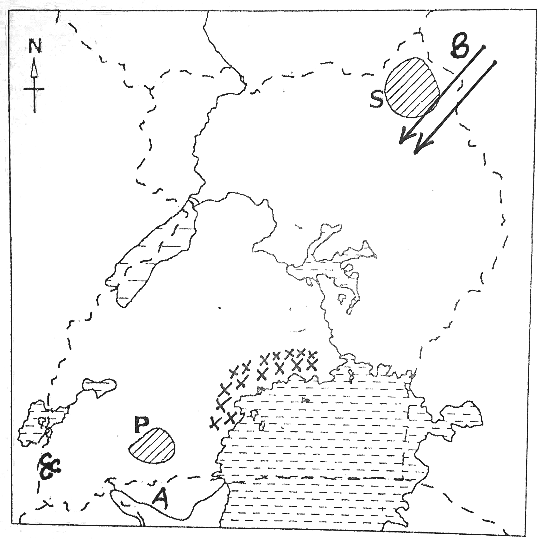
(a) Name the river marked with letter A.
____________________________________________________________________
(b) Give any one tribe which migrated into Uganda using route marked B.
____________________________________________________________________
(c) Which tourist attraction is found in the place marked C?
____________________________________________________________________
(d) Why does the region marked xxx receive plenty of rainfall?
____________________________________________________________________
____________________________________________________________________
48. (a) Name the largest fish caught in Lake Victoria.
____________________________________________________________________
(b) Give two traditional methods of catching fish in Uganda.
(i) ____________________________________________________________________
(ii) ____________________________________________________________________
(c) Why is it bad to catch fish using poison?
____________________________________________________________________
____________________________________________________________________
49. (a) The table below shows tribes and the legends that they tell. Study and complete it correctly.
 | Legend | Tribe
(a) | Mundu and Seera | _____________________________
(b) | _______________________________ | Baganda
(c) | Bachwezi | _____________________________
(d) | ________________________________ | Acholi

50. (a) Name the British official who brought Sudanese soldiers in Buganda.
____________________________________________________________________
(b) Name any one fort built by each of these personalities in Uganda.
(i) Sir Samuel Baker: ___________________________________________________
(ii) Sir Gerald Portal: ___________________________________________________
(c) Why were Sudanese soldiers brought in Buganda?
____________________________________________________________________
____________________________________________________________________
For each of the questions 51 to 55, answer EITHER the Christian OR Islamic question, but not both. No marks will be awarded to a candidate who attempts both alternatives in a number.
51. Either:
(a) What is the meaning of prayer?
____________________________________________________________________
____________________________________________________________________
(b) Who taught Christians how to pray?
____________________________________________________________________
____________________________________________________________________
(c) Why do Christians kneel when praying?
____________________________________________________________________
____________________________________________________________________
(d) Why do Christians close their eyes when praying?
____________________________________________________________________
____________________________________________________________________

Or:
(a) What is Salat?
____________________________________________________________________
____________________________________________________________________
(b) Who taught Muslim believers how to perform Salat?
____________________________________________________________________
(c) Why do Muslims wash parts of their bodies before performing Salat?
____________________________________________________________________
____________________________________________________________________
(d) Why do Muslims remove their shoes before entering a mosque?
____________________________________________________________________
____________________________________________________________________
52. Either:
(a) Mention the name of the mother of Jesus.
____________________________________________________________________
(b) In which town was Jesus Christ born?
____________________________________________________________________
(c) Who was the earthly father of Jesus Christ?
____________________________________________________________________
(d) Why did Jesus come on earth?
____________________________________________________________________
____________________________________________________________________
Or:
(a) Mention the name of the mother of Muhammad (P.B.U.H)
____________________________________________________________________
(b) In which town was Muhammed (P.B.U.H) born?
____________________________________________________________________
(c) Who was the father of Muhammed (P.B.U.H)?
____________________________________________________________________
(d) Why did Allah send Prophet Muhammad (P.B.U.H)?
____________________________________________________________________
____________________________________________________________________

53. Either:
(a) Give any two things a Christian is expected to do during Lent.
- ____________________________________________________________________
- ____________________________________________________________________
(b) In which two ways does fasting help a Christian?
(i) ____________________________________________________________________
____________________________________________________________________
(ii) ____________________________________________________________________
____________________________________________________________________
Or:
(a) Give any two things which a Muslim is expected to do during the holy month of ramathan.
- ____________________________________________________________________
____________________________________________________________________
- ____________________________________________________________________
____________________________________________________________________
(b) Give any two groups of people who may be excused from fasting.
(i) ____________________________________________________________________
(ii) ____________________________________________________________________
54. Either:
Choose the correct name in LIST A to complete the statements in LIST B
LIST A LIST B
Thomas buried the body of our Lord.
Amos doubted that Jesus had risen.
Simon Peter fed on honey and locusts.
Judas Iscariot denied the Lord three times.
John the Baptist
Joseph of Arimathea
(a) _________________________ buried the body of our Lord.
(b) _________________________ doubted that Jesus had risen.
(c) _________________________ fed on honey and locusts.
(d) _________________________ denied the Lord three times.

Or:
(a) Apart from Salat, list the other pillars of Islam.
(i) ____________________________________________________________________
(ii) ____________________________________________________________________
- ____________________________________________________________________
- ____________________________________________________________________
55. Either:
(a) Who was sent by God to rescue the Israelites from Egypt?
____________________________________________________________________
(b) Mention any three ways in which the people of Israel suffered while in Egypt.
(i) ____________________________________________________________________
(ii) ____________________________________________________________________
- ____________________________________________________________________
Or:
(a) Give any two duties of the angels of Allah.
- ____________________________________________________________________
____________________________________________________________________
- ____________________________________________________________________
____________________________________________________________________
(b) Give two ways in which a Muslim promotes and shows friendship and brotherhood to others.
- ____________________________________________________________________
____________________________________________________________________
- ____________________________________________________________________
____________________________________________________________________

Good luck

